Paul Klee printing

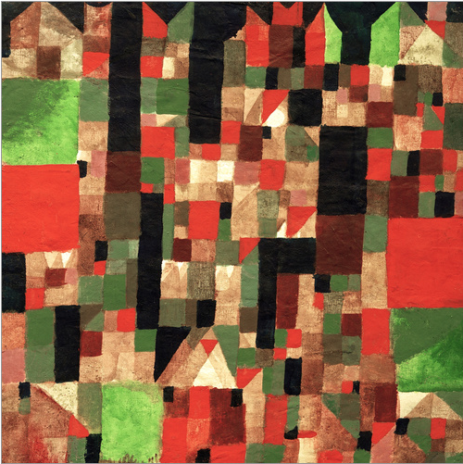
Paul Klee, Cityscape

You can try printing at home with all sorts of everyday items such as Lego blocks or leaves, or you can (carefully!) carve your own stamps out of firm vegetables like potatoes or carrots. You can then use stamping ink blocks, paint or felt pens to colour your stamp. Try different methods and make a note of the changes you see. Can you overlay your stamping to produce different colour blends and combinations?
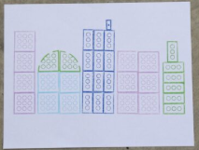 Example of Lego printing

