Persuasive Writing
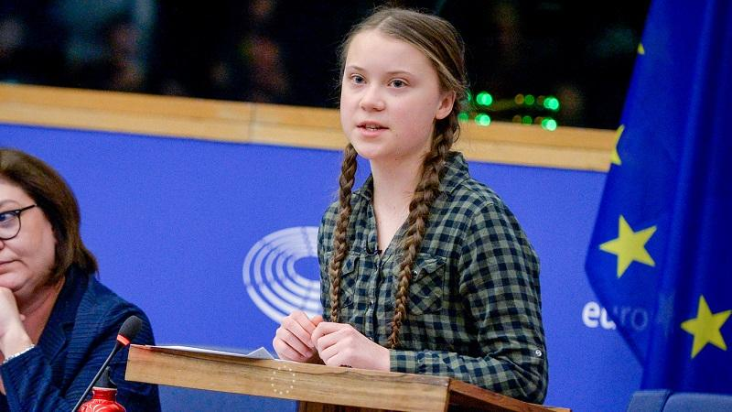

Greta Thunberg is internationally known for her efforts in battling climate change. She is just a young girl who, with the right words, believes she can make a difference. Take some time to watch her in action as she tries to persuade those in positions of power that change is urgent.
https://www.fridaysforfuture.org/greta-speeches
Have a go at writing your own speech. What is it you feel is vital? Why is it important? What will happen if we don’t make these changes? Why is that so devastating?
Here is a little prompt of features of persuasive writing.


