The old man from The Tin Forest
Can you copy this into your Home Learning Journal using the same drawing and colouring style as Wayne Anderson?
Which adjectives would describe him? Write some around the picture.

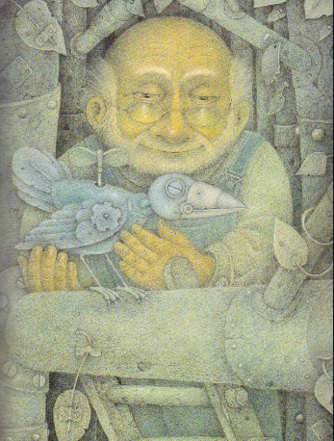
caring

gentle
Write a description of the old man
In a windswept, abandoned place, an old man….

