Persuasive Writing
You could be persuasive on a poster. Your poster could be about what you have enjoyed on your walks during lockdown.
Slow worms are beautiful because…
We should protect them so…
Did you know….?
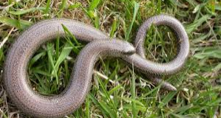
I have seen many different kinds of trees on my walks including…
Trees are important because…
With trees, you can…
What else have you seen on your walks?
Birds?
Insects?
Plants and flowers?
Draw them and write about their beauty, their importance, how we should protect them.
Think of a slogan e.g. Nature is good for you because…



