Term 1 Newsletter EYFS

Dear Parents and carers,

Your child’s adventure on their journey through school has begun! We are delighted to have them join Apple Class and to be able to embark on this venture with you. We will upload photos and information to Tapestry regarding your child’s progress at school. As we share the responsibly for the development of your child with you, please could you kindly like and/or comment on the observations. To share your side of your child’s progress, please upload your own photos and comments of your child’s achievements at home.

Each term, your child will bring home a 'knowledge organiser' with pictures and vocabulary for their next Learning Experience. The knowledge organiser can be used as conversation starters with your children to find out what they have learnt at school. In addition to the Learning Experience, we will also follow child interest through our continuous provision and story times.
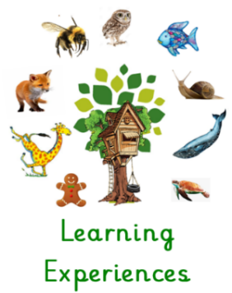
Curriculum Outline Term 1
Our first Learning Experience is ‘Once Upon a Time’ which we will launch during the week of 14th September. The children will explore traditional tales, including, The Three Little Pigs, Little Red Riding Hood, The Gingerbread Man, Goldilocks and the Three Bears and The Three Billy Goats Gruff. The children will be acting out these stories, using the language of traditional tales, sequencing sizes of teddy bears and other toys and learning about the suitability of different materials for building.

Homework
On Thursday afternoons, Apple children will visit our school library; your child will choose a library book, and this will be in their book bag. Please enjoy the story book with your child, making sure to place it back in the book bag every day. On Fridays, your child will be bringing home a weekly homework task linked to the current Learning Experience; when this is completed, please share your child’s work by posting photos on Tapestry. In due course, your child will bring home a school reading book, linked to our phonics scheme. I will send more detailed information regarding reading homework at that time.

Uniform
Your children have started this term looking very smart in their new uniforms. As your children grow, remember that our lovely PTA run a uniform shop, which is well-stocked and open regularly. PE for Apple Class is on Tuesday, so please send your child into school dressed in their PE kit.

Dates for the diary
PE will take place on a Tuesday for Apple Class. Please could children come into school wearing their PE kit on this day. You can also find all important dates on the school website and on our weekly school newsletter:
Borough Green Primary School - Home (bgpschool.kent.sch.uk)

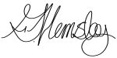
Kind regards,

Mrs Hemsley
EYFS Leader @ BGPS

