(Day 1)
Pacific Coast: South Coast Road Trip
Eleanor
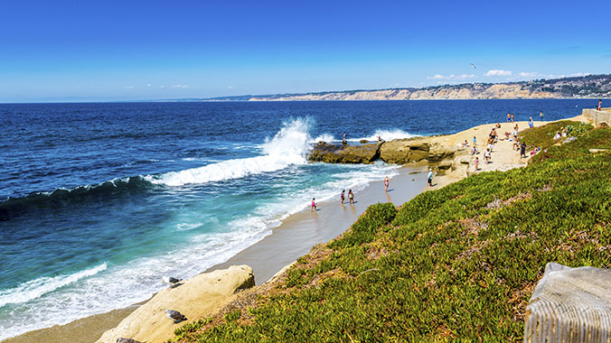
After a while, I managed to tear myself from the intense beauty of the forest and headed down to the beach. Glistening waves would collide with the rocky surface; serenity was an illusion. Champion surfers –the iconic sea otters- were racing through the strong sea; you could hear their happy cries. Later while I was scuba diving in the deep seaweed forest, graceful otters were chomping on their food: starfish, fish and other sea creatures that are small and tranquil.

Behind the enchanted forest, I could see the sublime sunset that was born from fire slowly setting. I was stunned by the fierce beauty of the moonlit woods. Moving on, I saw the pleasant, endless meadows; it made me feel calm and relaxed. Stunning cougars (the fiercest predator in the golden state of California) were prowling through the remarkable oak woodlands.

However much I loved the sea otters, I have to move on. I could hear the ruthless rattling of the rattlesnakes as condors swooped around in the cloudless sky. I was literally struck mesmerised as if walking through a magical land. Every landmark could be a postcard: the tall redwood trees, the restless but shining ocean or the rocky coast; I never want to leave this astonishing state.

Come and see this extraordinary experience, it’s quite galvanizing; the sea’s buzzing with its dormant strength while the white sand, almost as blinding as snow, reflects the hot sun back at you until you’re dropping with perspiration—it provides you with an unforgettable holiday and a great tan!

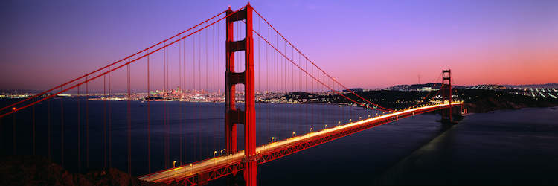 The Magnificent Golden Gate Bridge (Day 2)
After journeying to the Pacific Coast, I decided to visit the breath-taking Golden Gate Bridge, first opened in 1937. It was once called ‘’the bridge that could not be built’’, but now in the present, it is one of the seven wonders of this modern world. I guarantee it’s one of the most beautiful places I’ve ever been to; I could see the mist gently hover under the stunningly-high bridge as the deep aqua-blue sea swells below. I travelled to some amazing spots to sight see: the Pierre; Battery East, Crissy Field—there’s many more! These places are phenomenal spots to take magical pictures.

Known as one of the most famous attractions in California, the Golden Gate Bridge is mostly famous for its graceful lines, remarkable view, Art Deco detailing and it’s emblematic colour. Whether you’re walking, cycling or driving, I think it’s always an eye-grabber. Painted in International Orange, the Golden Gate Bridge is not actually golden itself: it’s named after the glistening sea below.]

The spectacular beauty of the engineering marvel is an opportunity of a lifetime in my opinion. From my experience, it can also be very alluring at night too: the lighting makes it seem as if the web-like spires of the towers dissolve into the pitch-black. The elegant mist is the most enchanting in the morning when it’s shrouding the orange bridge.

I really recommend to visit The Golden Gate Bridge—it’s heart-stopping; the sublime sunsets, the sensational sightseeing spots and the unfathomable sea—it’s just too beautiful. The enthusiastic bright lights of the bridge guide you towards the sparkling metropolis of California.

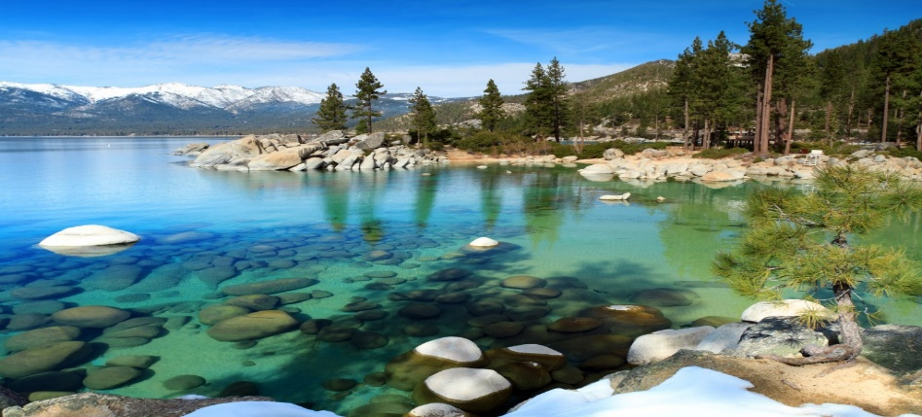

Sierra Nevada and Lake Tahoe (Day 3…The last day)
The last place I visited was the famous Sierra Nevada Mountains and it was marvellous. If you ever get an opportunity to go, I’ve got to warn you, it’s outstanding! I guarantee you’ll love it. Its environment is its own natural beauty; just imagine a beautiful, green wilderness with snow-tipped mountains so high up that they’re above the wondering clouds.

If you ever get lost, the greenness will guide you to a popular landmark—Lake Tahoe. Its glimmering surface reflects the burning suns’ shimmer- I am so happy that I saw it with my own eyes rather than from an unrealistic computer screen. Also in your journey you’ll see the recommended General Sherman: it’s the tallest redwood tree in the world.

This is a wonderful experience, especially Death Valley: its dry, scorching, hot sand will gently burn beneath your feet as you feel the real heat of California. To be honest, I was awestruck as I saw this phenomenal landmark; this is surely a must-see sight.

