
Vikings: Raiders, Traders or Settlers?
KS2: Years 5 and 6 | History and Geography
What should I already know about? | Vocabulary
- Chronology  - The Romans – legacy and the end of occupation  - Anglo-Saxons – settlement and way of life, including Crime and Punishment  - Myths and sagas: Beowulf  - Understanding sources and how to use evidence  - Religious artefacts and buildings such as monasteries and the role of monks.  - Lancashire as a region of the UK and California (North America) | chronology | trade, trader | stereotypical |  | stern
 | century | raid, raider | bias, biased |  | bow
 | legacy | spoils | burial site |  | chronicles
 | occupy,  occupation | archaeologist, archaeology | longship |  | social status
 | settle, settlement | excavation, excavate | clinker |  | domestic
History Skills | Key Knowledge
- I understand how bias in evidence can lead to stereotypical views of the past which need to be reconsidered;  - I know that interpretation of evidence is key to understanding the past;  - I understand that our knowledge of the past is constructed from a range of sources | Where did the Vikings come from? – Scandanavia  What is special about their ship-building? The way they shaped wood with an axe and the clinker design |  |  | Why did they come to Britain? – initially to improve their lives through raiding; later for the warmer climate.
 | When did the Vikings settle in Britain? First raid 789 AD, settled 793 AD, conquered York (Jorvik) 866 AD, ruled all of England 928 – 939 AD, final defeated in 1066 AD.  Evidence: letters, chronicles and excavations. |  |  | What is an accurate view of Viking people and Viking culture?  Successful raiders concerned with status, skilled craftsmen, family-focused farmers.
Geographical Skills | 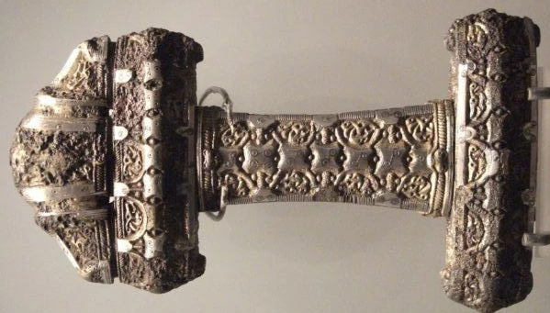  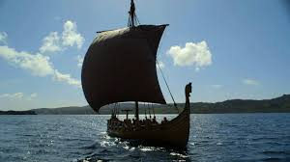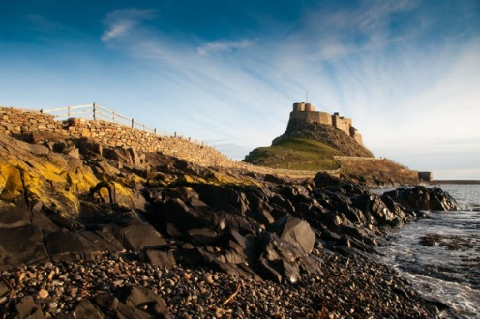  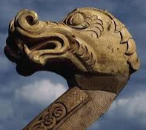  Viking wood - carving and longship  Lindisfarne  Viking metalwork
- I understand the difference, and can give examples or, human and physical geography
- I can describe how the UK differs from or is the same as Scandanavia and North America



